

Assessment Feedback Sheet

|  |  |
| --- | --- |
| **Overall Assessment Grade Achieved** |  |

|  |  |  |  |  |  |
| --- | --- | --- | --- | --- | --- |
| **Learner Name** | | **Husnain Ahmed** | | | |
| **Assessor Name** | | **Mohammed Abbas** | | | |
| **Qualification Title** | | Pearson BTEC Level 3 National Extended Diploma in Computing | | | |
| **Unit/Module No./Title** | | Unit 8: Business Applications of Social Media | | | |
| **Assignment No./Title** | | **8.1 Business Applications of Social Media** | | | |
| **Learning Aim(s)** | | **Learning Aim A:** Explore the impact of social media on the ways in which organisations promote their products and services | | | |
| **Issue Date** | **08/11/2019** | **Planned Submission Date** | **29/11/2019** | **Actual Submission Date** | **27/01/2020** |

|  |  |  |
| --- | --- | --- |
| First/Second Submission | | |
| Criteria | Criteria Achieved | Assessor’s Feedback *Your feedback should include:*   * *What the learner has done well. (Knowledge, skills, etc.)* * *What the learner has not achieved and what was missing.* * *Information or guidance available to the learner they could have drawn on (e.g. class notes; handouts; resources in assignment brief etc.)* |
| P1  Explain the different ways in which an organisation can use social media to promote products or services to a target audience. |  |  |
| P2  Explain the audience profiles of different social media websites. |  |  |
| M1  Assess the different ways in which an organisation can use social media to promote products or services to a target audience. |  |  |
| D1  Evaluate the organisational use of social media to interact with customers and promote products or services to a target audience. |  |  |
| **BTEC Rules**  All resubmissions must be authorised by the **Lead Internal Verifier**. Only **one** resubmission is possible per assignment, providing:   * The learner has met initial deadlines set in the assignment, or has met an agreed deadline extension. * The tutor considers that the learner will be able to provide improved evidence without further guidance. * Evidence submitted for assessment has been authenticated and accompanied by a signed and dated declaration of authenticity by the learner.   Any resubmission evidence **must** be submitted within 10 working days of receipt of results of assessment (BTEC only) | | |
| **Wider Skills (Linked to Positive Futures)** *Comment on the quality of the learner work, the learner’s process and practice during assessment, research skills, presentation, general behaviour and conduct, meeting deadlines, etc.* | | |
|  | | |

|  |  |  |  |
| --- | --- | --- | --- |
| Assessor Declaration | *I certify that, to the best of my knowledge, the evidence submitted for this assignment/assessment is the learner’s own. I understand that false declaration is a form of malpractice.* | | |
| Assessor Signature: |  | Date: |  |
| Learner Declaration | *I certify that the evidence submitted for this assignment/assessment is my own. I have clearly referenced any sources used in the work. I understand that false declaration is a form of malpractice.* | | |
| Learner Signature: |  | Date: |  |

**Learner Actions**

|  |  |
| --- | --- |
| Learner’s Targets/Actions  *What needs to be developed to improve future work?* | *Actions linked to the following Positive Futures outcomes* |
|  | * Confidence * Commitment * Collaboration * Resilience |

**Impact of social media and how the ‘Chamber of Commerce’ can use it**

In the current time, there are lots of social medias that can be used to upload images or videos, talk to your friends and family, or even just talk about random topics you are interested in, and on these there are a lot of advertisements for organisations that are (usually) relevant to you and will be about things that you will be interested in buying or engaging with.

There is online and offline advertising, ways to advertise offline include leaflets, posters, billboards and word of mouth. These are better than social media advertising on the web in short distance and local areas. A negative is that if you are not a local business this in not very efficient and is a waste of time and effort. This is all to be useful for small businesses as well as there are too many businesses advertising on the internet and there is a small chance of someone seeing your ‘no name company’ with no reputation and deciding to learn more about it instead of simply ignoring it and carrying on with their day. An example of this would be a small take away or chippy which would be local, if someone sees a leaflet or poster that it is opening close to where they live, there is a good chance that they will check it out as it is in a convenient walking distance and if they enjoy it they may tell their friends to try I tout and its influence will only spread more from there on.

The mainstream social media platforms are Facebook, Twitter, Instagram, Snapchat and YouTube. I will explain a little bit about each of these platforms to you, and how you can make use of these to advertise online.

YouTube can be accessed from devices with Internet connectivity. Users can create a customized profile called a ‘channel’ where they upload videos that can be set to ‘public’ which means that anyone can see them, ‘private’ which means that only they can see them and ‘unlisted’ which means that people can only see them if they have the link to the video. It is different from the other social medias (it doesn’t let you post pictures or status updates but you can do videos for this purpose anyway like vlogs) as its purpose is solely to upload and watch videos of all genres that can range from 1 second to 24 hours or even livestreams. Companies can advertise their products on advertisements that show up on videos or pictures on the side of the videos like popups, they can also directly sponsor famous youtubers and pay them to talk about their products (this is useful because the youtuber usually puts their own spin on how they present the company and it is more often than not very engaging and will not be skipped by viewers, unlike the skippable 5 second adverts at the start of the videos), an example of a company that does this is ‘Loot crate’. Their crates are full of gamer related content from custom controller skins to plushie toys of famous game characters. Loot crate sponsors youtubers that are involved in gaming or tech content such as Syndicate or LinusTechTips. This ensures that the people who see the videos, and in turn see the sponsorship will know about it and they may buy it as it interests them and they may have seen the youtuber use the product. They will want it because it relates to them or just because it’s something that can help out their favourite youtuber such as a coupon code that will save them money and also give more money to the youtuber every time someone uses it. You can use this to interact with people in the area and promote things that are happening in the local area under your jurisdiction, like festivals or new businesses. The chamber of commerce can use YouTube to post reviews of businesses and going in to buy things and view the products like the “Chicken Connoisseur” does.

There is no intended age for the audience as there is a large variety of genres of videos that can be viewed from music to games to news, the possibilities are endless.

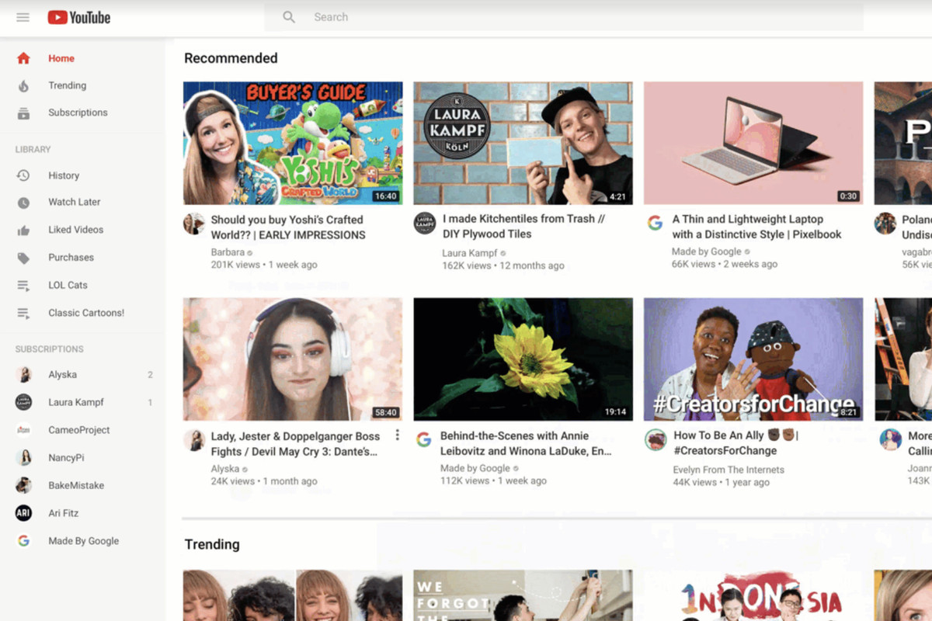

On the left there is the menu and all of the different functions you need to navigate YouTube, on the top is a search bar you need to look for specific videos. In the middle there is recommended videos to watch and on the left there is (not on this picture because it is cut off) advertisements. They are here in their own section secluded form the rest of the content and are very eye catching

Facebook can be accessed from devices with Internet connectivity. Users can customise their profile to show or not show personal information about themselves. They can post text and media which is shared with any other users that have agreed to be their friend or anyone if they are not set to private (you should do this). One way to advertise is by using these media such as a picture or video of your product with a quick and informative description and a link to your website or a page with more data. You could also use video poll ads which incorporates an interactive component with video polls and let the users interact with and vote on one of the options that interest them, for example choosing option ‘A’ instead of ‘B’ or ‘C’. You can also use carousel ads which use up to 10 videos or images to show your product, this can be used to showcase different benefits of a number of different products, or use all the photos together to create one big panorama image. Users can also use various embedded apps and games, join common-interest groups, and receive notifications of their friends’ activities (which would be useful for the followers of the chamber of commerce as they will be notified of recent events in their area). Companies can advertise their products on the right-hand side of the screen. The chamber of commerce can use this to post ads and notifications about businesses and can have ways to contact them if small time business owners would like their endorsement and advertisement.

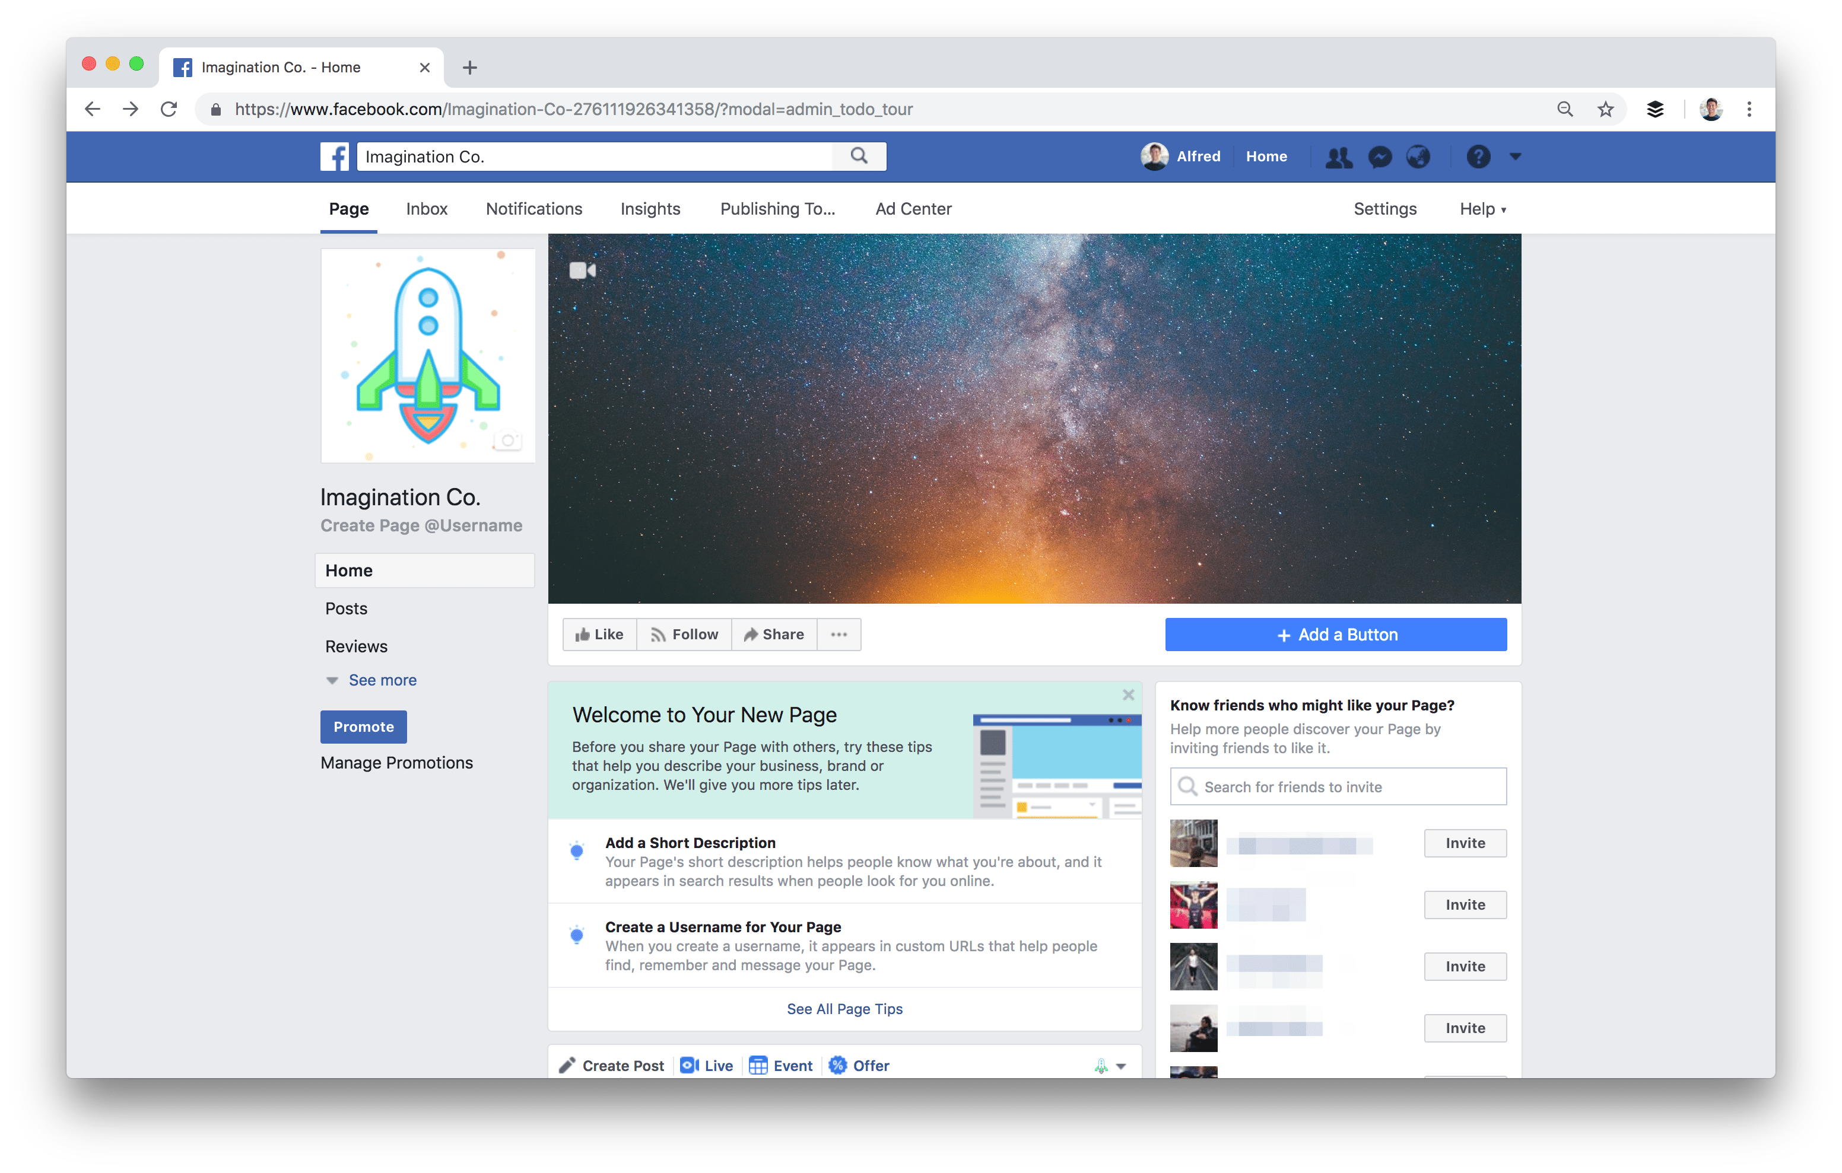

At the top can be a picture that shows the business and underneath there can be information relating to the purpose of the company and their services.

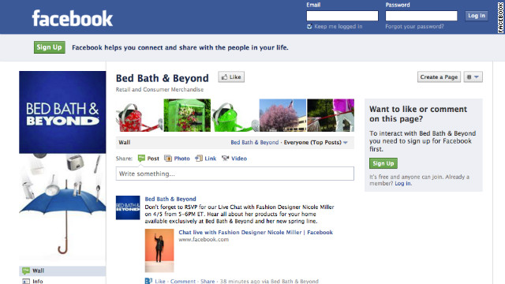

This is an example of a company advertising their services on Facebook.

Facebook is targeted at the older generation as it is more professional and is used by them more as it was around then, they attempted to make it viable to the younger generation by adding games but that didn’t really work.

Facebook analytics is more used

Google Analytics is used by google to

Instagram allows users to upload media along with a description and location to their followers or anyone who views the profile if they are not on private settings. Pictures can be edited with different filters and drawings or texts. An account's posts can be shared publicly or with pre-approved (chosen) followers or anyone if they have no privacy settings enabled. Users can browse other users’ content on their profiles, and view trending content. Users can "like" photos, and follow other users to add their content to a feed (the home page, which has posts of the people you follow). Ads on Instagram can be either picture or video ones which are just a regular post on a company account about the product or service. There are also story ads which disappear in 24 hours. There are also IGTV ads which are chosen by Instagram and sponsored ads by people who have paid Instagram to show their ads to everyone. The chamber of commerce can upload pictures with locations of new businesses to get them more publicity.

These ads are usually seen when scrolling through your feed and are tailored based what you follow and like, so they will be relevant and be taken very well and the product will have a high chance of being used or bought.

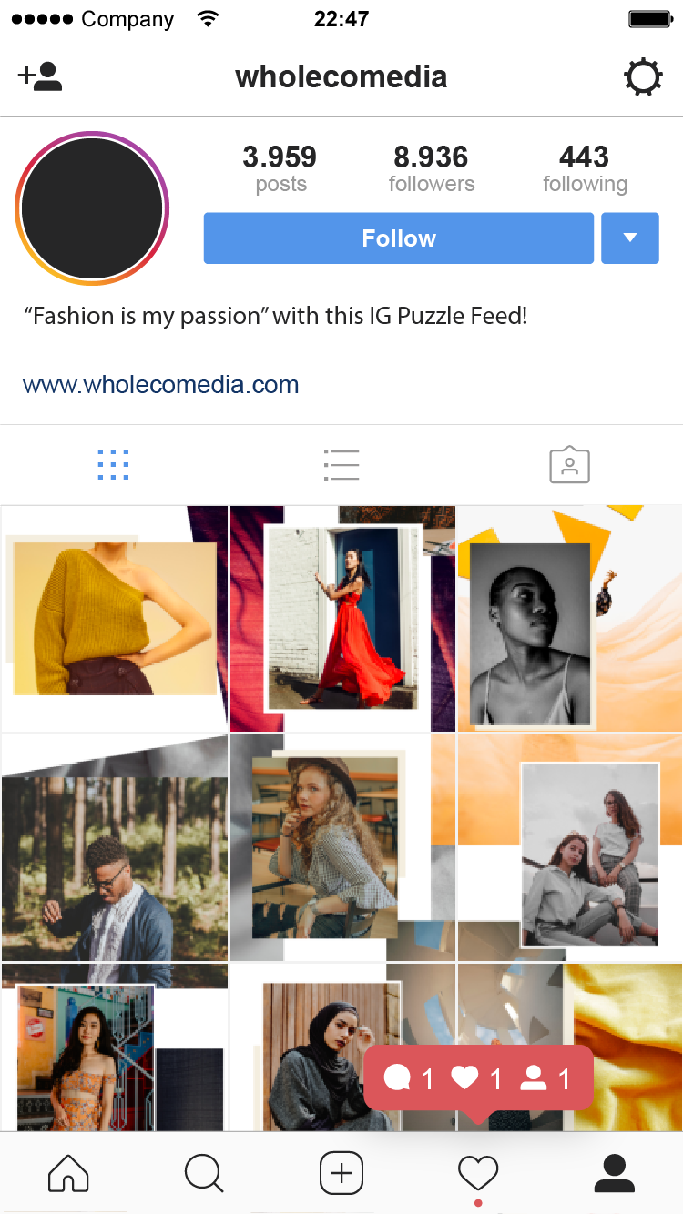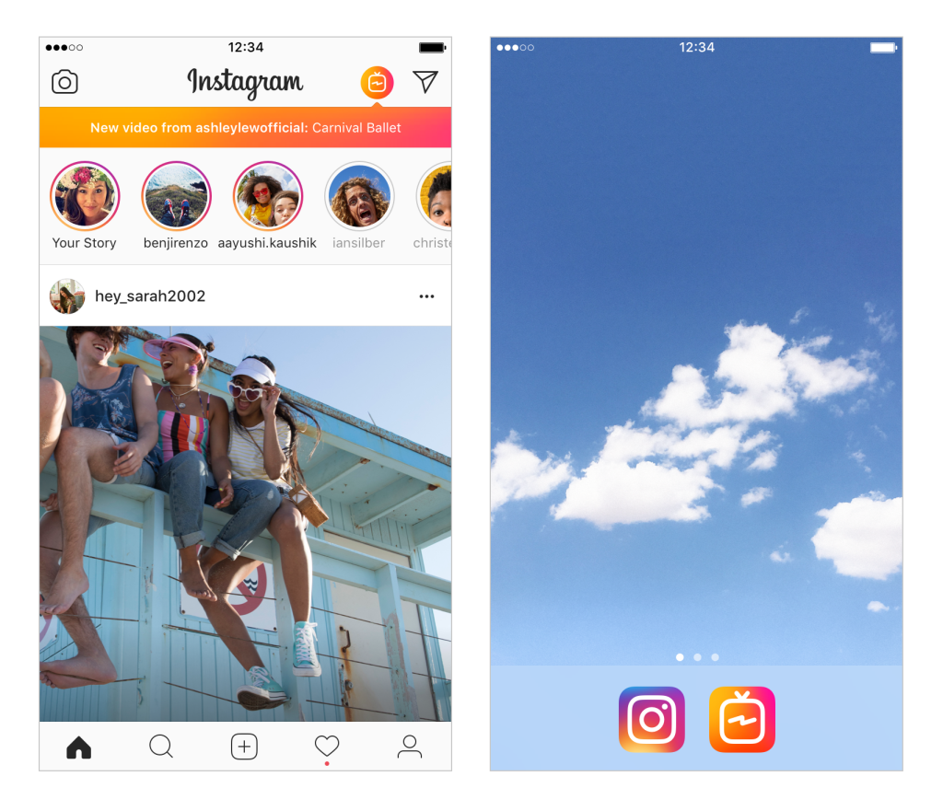

The picture in the middle is the home screen from there you can easily access the search function, the upload function, the liked posts function and the profile function from the buttons on the bottom bar. At the top right you can success your private messages, group chats and live TV streams. The top bar also has the Stories of the people you ‘follow’. Then ‘feed’ or homepage can also have advertisements which is where the chamber of commerce can advertise their services and other businesses too.

Instagram is targeted at individuals between the ages of 13 and 30, it is more simplistic that Facebook and is easier to use but it also is a hub for different types of media, such as memes which are usually intended for the younger generation and are very trendy anfad influential in our society.

Snapchat is used to send pictures and messages that are available for a short time before they become inaccessible to their intended audience be it a private message to a friend or a story that anyone can view for 24 hours. There is a function called "Discover" that lets brands show adverts and their products. Adverts on snapchat can be articles, videos or pictures.

Articles can be on pretty much any subject but are mainly used for the news channels like ‘brother’ and ‘foodie’. This probably won’t be used by the chamber of commerce as it is usually personal things and is not very good for news even though it is possible but there is a low chance of it reaching the intended audience. These adverts are in the form of interesting videos and news clips some of them that cover controversial and trending topics, so they are more likely to be remembered.

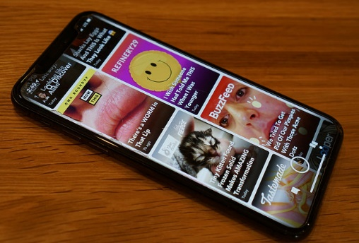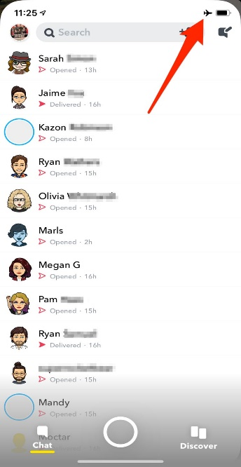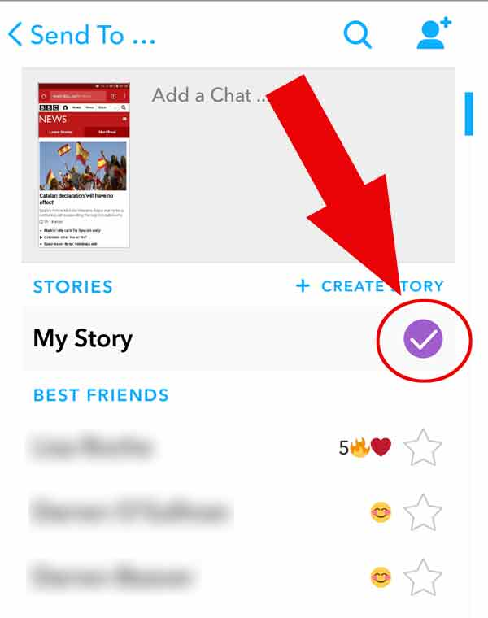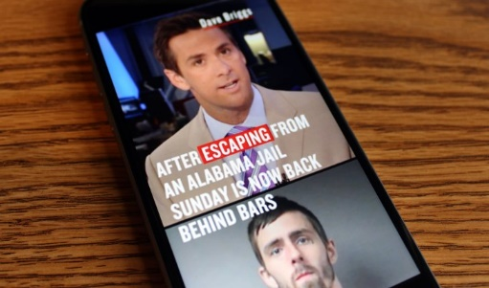

Snapchat has a profile screen where you can view you friends and your own picture / profile name and code. It also ahs a screen where you can view all of your private messages as well as your group chats. I have also shown how to add things to your ‘story’, as well as the news function. The news function can be used for advertisements by different companies as well, and the Chamber of Commerce will find it very useful in conveying their messages to their intended audience.

Snapchat is aimed towards the younger generation and this is shown by the news which are all about trending and influential events, but food, memes, jokes and different hobbies.

Twitter is a microblogging and social networking that users can be used to post messages and texts called "tweets". You can advertise on this through promoted tweets, promoted accounts or promoted trends. These are all shown to you if they are of any relevance to you based on the information they have on you such as your liked subjects or search history, such as adverts for installing apps if you play games linked to your twitter account and such. Or you could have an account dedicated to your business and send tweets to your loyal followers who will be interested in your services. You can also post media such as pictures or videos. The chamber of commerce can use this to tweet names and purposes of local businesses that have promising futures.

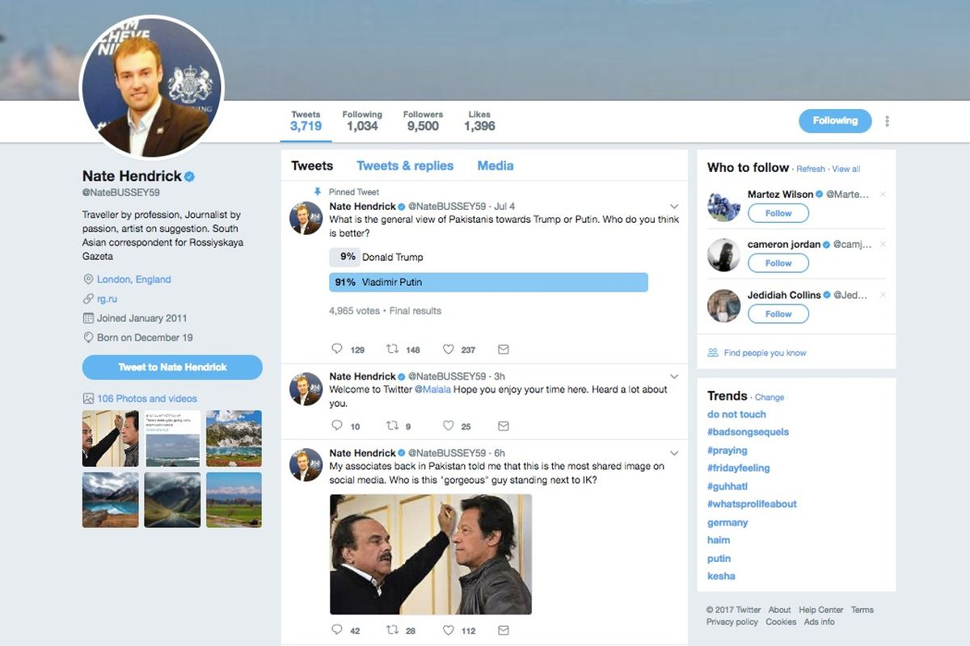A Twitter page is mainly for showing off the recent events and can keep people up to date on current events, this will be good for the chamber of commerce to inform people about up and coming new businesses and relevant events, an example of this is apple advertising the up and coming iPhone.

Twitter is intended for adults as 40% of U.S. adults who use Twitter are aged between 18 and 29 years. This shows as a lot of the most influential people on twitter are politicians and news stations.

YouTube and Instagram are some of the best for advertisements as YouTube will be much more interactive and have a much broader audience than the others and can be used in conjunction with Instagram and can post video links on your profile. Both of these have a very wide user audience which is not restricted by age, race, gender and are some of the most diverse and most informative social media platforms out there today.

Facebook and Twitter are very similar in the fact that they both primarily use text and images to convey their messages and broadcasts. On twitter your posts are open for anyone to view as long as they aren’t restricted by age, whereas Facebook is mostly restricted to your ‘friends’ or if you set your profile to public anyone can view it, so twitter may be better for businesses as they can be seen by anyone but the layout of Facebook is much better for this as there can be adverts on the sides as well as photos ant text in the middle of the screen.

Facebook and Twitter are better for notices as they are used for reminders on events that come up. Twitter is used to notify people of ‘What’s on your mind’ and can be mainly used to inform people of your recent events so people can keep up to date on the events of the businesses in their local area. Whereas Facebook will have a more mature audience and the ads are mostly going to be related to their search history so they will only see things that they would see as relevant or useful, whilst the council’s businesses would be relevant to them as they live in the area. The chamber of commerce can use both of these in conjunction to advertise up and coming local businesses to revitalise an area’s economy.

Analytics

Analytics are used to show the data of potential trends, to analyse the effects of certain events and decision or to evaluate the performance of a certain scenario or tool. The purpose of analytics is to improve a business by collecting knowledge which is used to make productive changes that will improve the business and gain it more attention on media and get more customers.

Google Analytics is for web analytics and it tracks / reports website traffic. This data is used to improve the marketing aspects of a business. It tracks things like the session duration, bounce rate and pages per session of individuals who use the websites which is factored into showing relevant adverts, so if they look at a lot of sports websites and videos they may receive adverts for running shoes or boxing gloves.

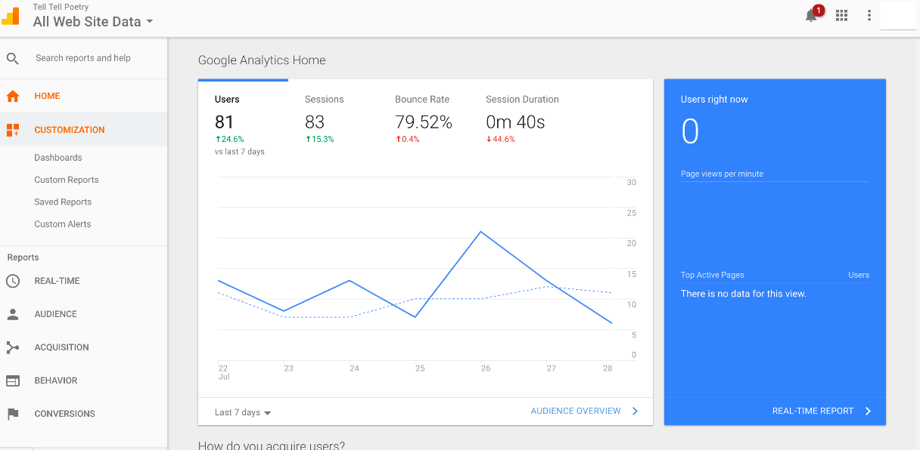

Facebook Insights is used to let marketers and business owners explore their consumers interactions with their page and how they engage with it. It can be used to determine the best time of day to post, the best day of the week to post and which content is most liked by your followers. It is constantly updated and reflects your pages development and any patterns that may occur.

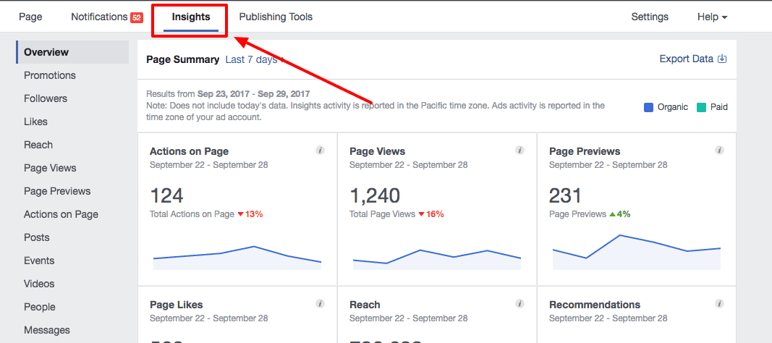

YouTube Analytics quantifies the successes and failures of your videos so you can post content that keeps your viewers engaged.

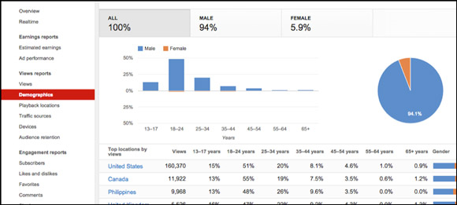

Twitter Analytics lets you see how many times your tweet showed up in people’s feeds, and you can get detailed breakdowns of how the impressions happened. It can also do this for click stats and engagement metrics such as likes and retweets. Over all it tells you where on the network that someone engaged with your post.

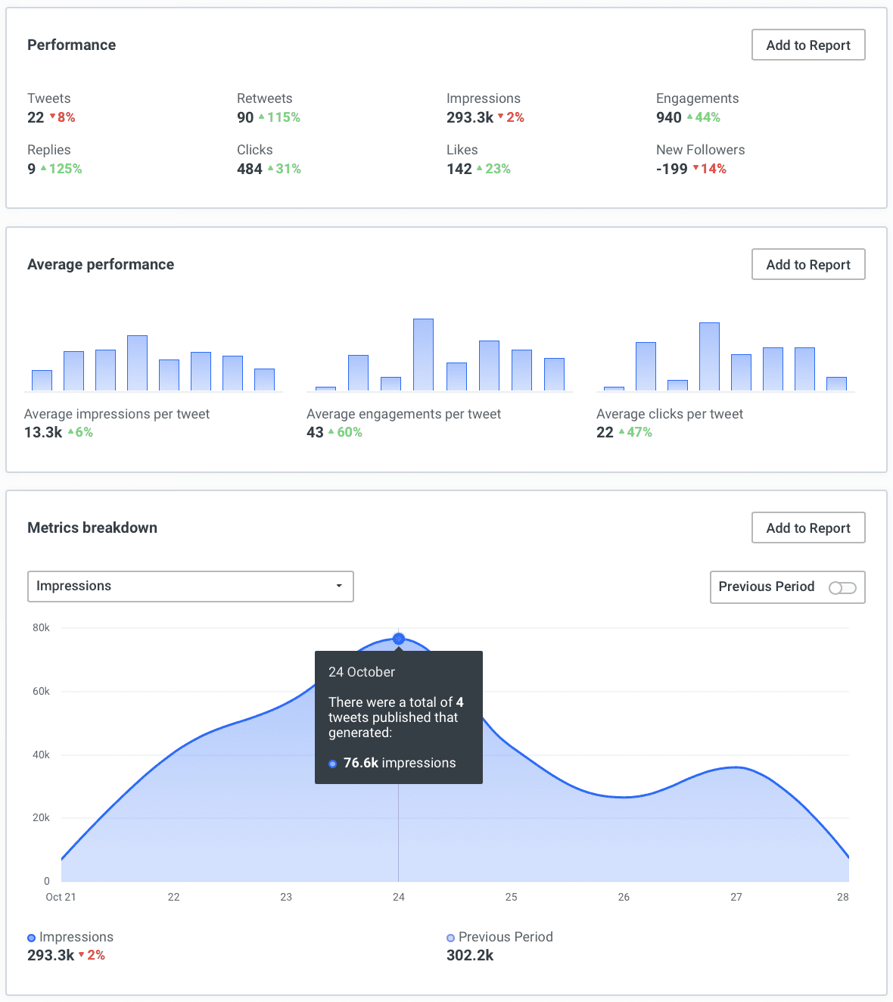

Search Engine Optimisation:

This is the way to increase the visibility of your page to users of a webpage or search engine, it increases traffic and visitors to your page and makes your page more likely to show up on the front of the search engine results page. It is optimising a page by adding content or modifying it, modifying HTML to increase relevance to specific keywords that are mostly used for the general theme of the page so people can find your page easier. For example if they type in cooking recipes a cooking page will likely show up.

Risks and issues:

One possible risk that can occur on social media is people not enjoying your content and posting negative and demeaning comments, these can hurt people’s feelings and are not very nice.

Your account can be hacked and people can post unwanted things on your account, this can be bad as it can tarnish your reputation and drive away potential customers.

People can also post negative or false feedback which will not give you a good reputation and will also drive away potential customers.

Conclusion

Overall it is possible to use any social media platforms but it is recommended that you prioritise using Facebook for your advertising and promoting your business as it is used by more people than others and has been around for a long time. It also contains a myriad of useful features that can be used to expand your influence and sell your products with different types of adverts, media or just texts (similar to tweets), it doesn’t have any restriction on the types of media and can reach out to a wide range of people. People who are interested in your business can also privately message you to find out more information. The adverts on Facebook are usually in your local area and so more people will know about them and may go to your business.

Review:

* Refer to the social media more. ✔
* Provide examples of actual companies using social media and look at factors that can impact a business. ✔
* Explain why the age range is the intended audience, and give reasons. ✔
* Refer to where the adverts are placed and why. ✔

